Guide for Preparing an Erosion and Sediment (E&S) Pollution Control Plan

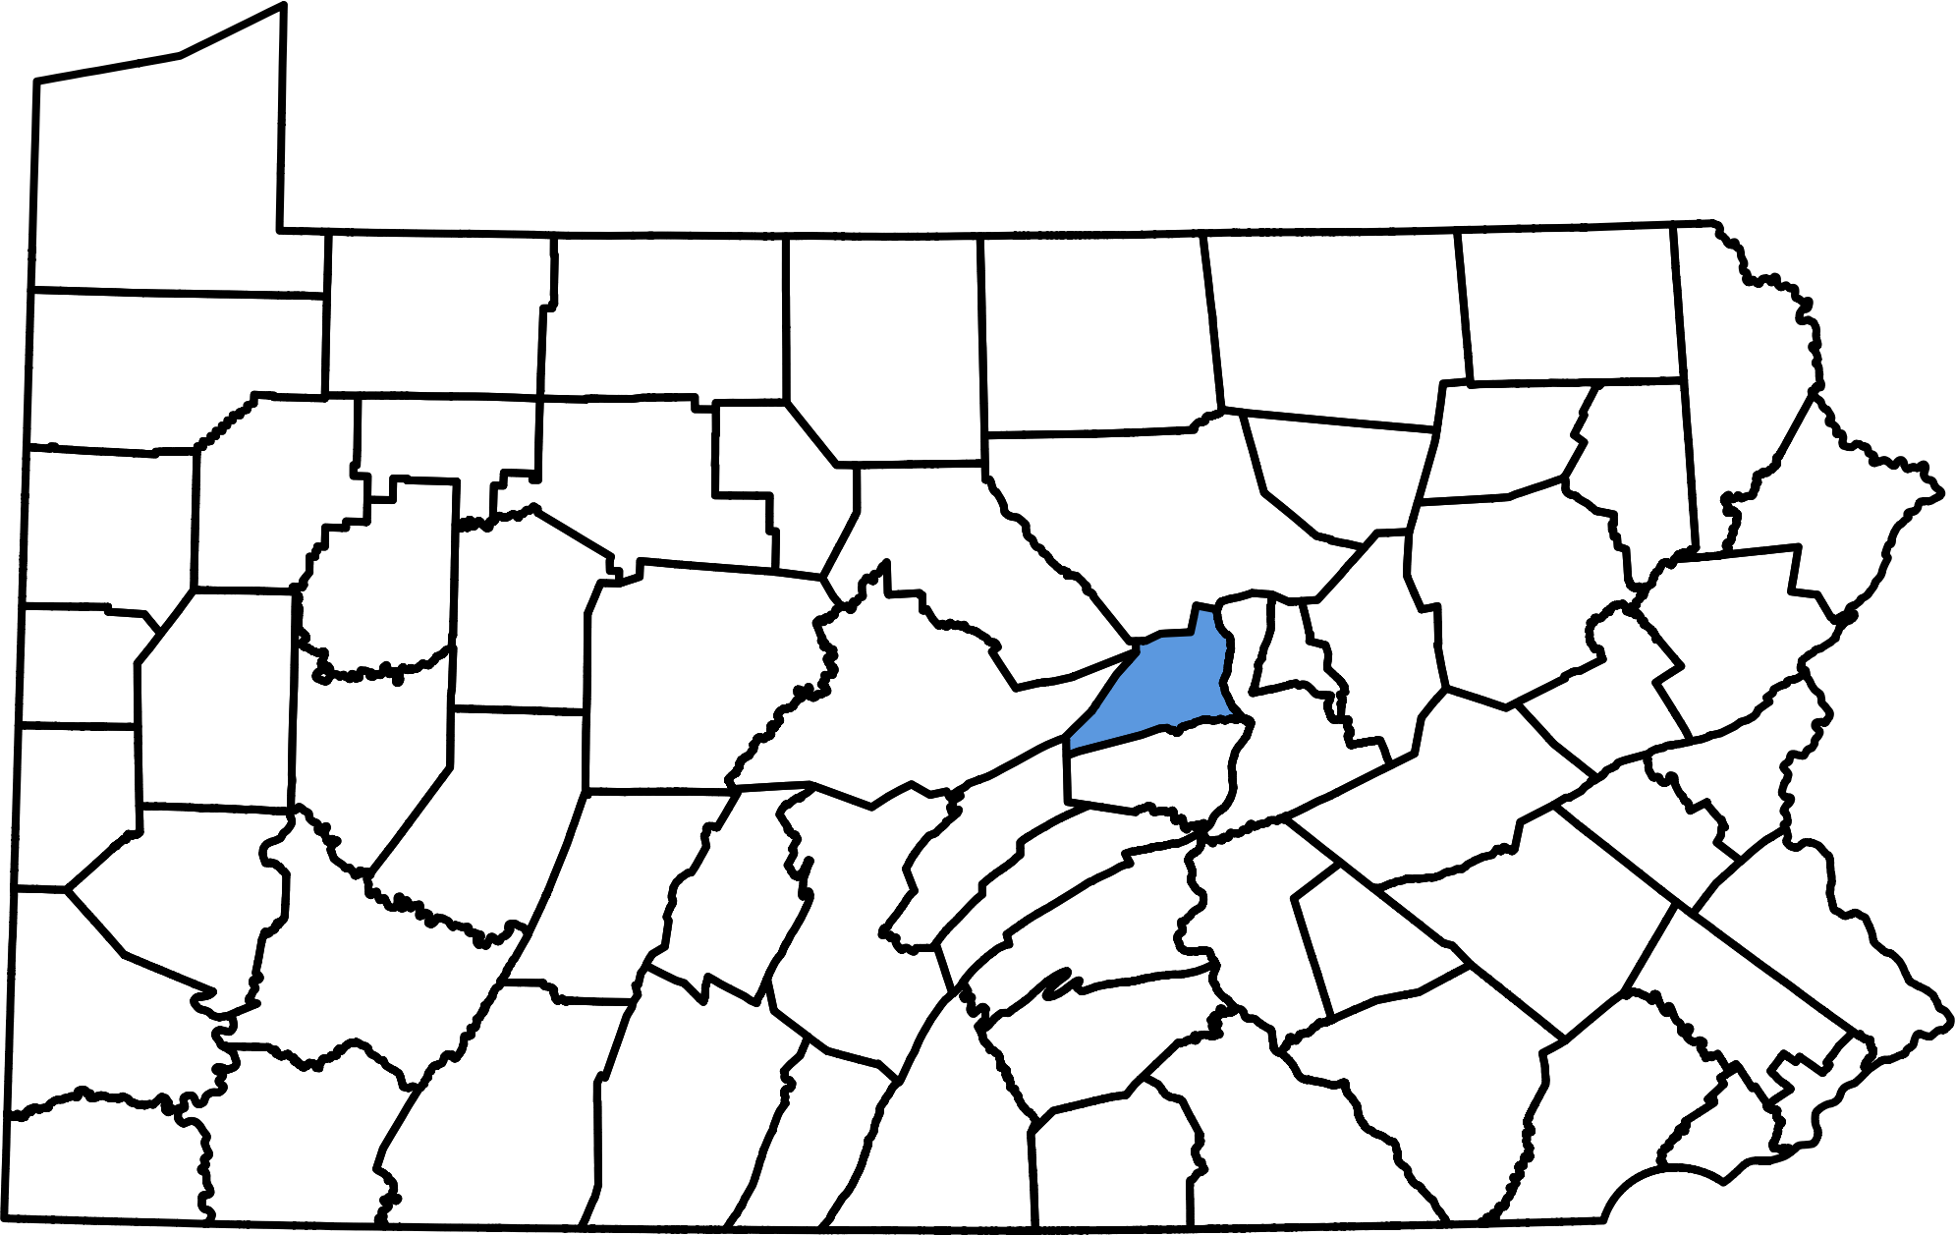

Union County, PA

Union County Conservation District
155 North 15th Street
Lewisburg, PA 17837
Office: 570-524-3860
Fax: 570-524-3873

Introduction

In an attempt to alleviate the growing problem of controlling sediment pollution, the Commonwealth of Pennsylvania, through the Department of Environmental Protection (DEP), adopted Chapter 102, Erosion Control Rules and Regulations. Chapter 102 requires that anyone undertaking an earth disturbance activity develop and implement an Erosion and Sediment (E&S) Pollution Control Plan. The plan must be submitted to your Conservation District for review if required by the local municipality or if requested by the District. The E&S Plan must be available at all times at the site of the earth disturbance activity, regardless of the size of the project. Failure to have an E&S Plan on site is a violation of Chapter 102.

Remember: Both landowners and contractors may be held responsible for any violations of Chapter 102 regulations.

This guide is intended only for small, low hazard projects where:

- Disturbance is less than one acre (43,560 sq. ft.)
- There are no steep slopes in excess of 10%
- There are no streams or major drainage courses

Contact Union County Conservation District (UCCD) if there are any questions regarding the suitability of this guide for your project. For larger, more complex projects, a detailed Erosion and Sediment Pollution Control Manual is available, or contact a consultant to aid in plan development. In addition, check with your local municipality regarding specific ordinances or permit requirements.

Guidelines for Developing & Implementing an Effective E&S Pollution Control Plan (adapted from York County Conservation District)

When developing an E&S Plan keep in mind the goal is to develop an effective and practical plan that you and/or your contractor can readily implement in the field and easily maintain during construction. The foremost goal of your E&S Plan should be to minimize accelerated erosion and deposition of sediment into waterways, roadways, and onto neighboring properties downslope of your earth disturbance activity. Here are several common-sense guidelines to consider in developing and implementing an environment- and contractor-friendly E&S Plan:

Protect streams, drainage ditches, wetlands, and other bodies of water. Make it a priority to avoid grading or other earth moving within at least 50 feet of a waterway. Preserve natural vegetated buffers. Riparian (streamside) buffers serve as sediment filter strips, provide important wildlife habitat, stabilize streambanks, and provide shade that cools stream temperatures for trout and other cold water aquatic life. Clearly mark or flag off these critical areas to keep construction equipment out. Diligently maintain all best management practices (BMPs) in these environmentally-sensitive areas. Secure required permits for any work proposed within a wetland or within at least 50 feet of a stream. When in doubt contact the Conservation District to request a site meeting.

Avoid disturbing steep slopes. Steep slopes are difficult to stabilize and present a danger to equipment operators. Avoid excessive cutting which can alter the groundwater system and expose spring seeps and unstable soils. Improperly compacted fill can be highly erosive and unstable. Practice proper site grading. Avoid road grades in excess of 10%. Excavated driveways often collect dirty runoff from the construction site causing sediment to be deposited onto roadways, neighboring driveways, and streams. Construct properly-spaced water bars or broad-based dips on long sloping driveways to direct water off of the roadway which slows the speed of runoff by reducing the length of slope. Provide a cross slope or crown (1/2” to 3/4” per foot) the center of the driveway.

Minimize the extent and time of disturbance. The more land area that is disturbed and the longer it remains exposed, the greater the potential for erosion and sediment problems. Allow undisturbed areas where work is not occurring to remain undisturbed for as long as possible especially over the winter months. Seed and mulch or otherwise stabilize areas on an on-going basis. Always seed and mulch immediately upon completion of final grade. Apply a stone base to the entire length of your driveway the same day it is excavated.

Keep clean water clean. When possible and prior to disturbing any earth install a stabilized temporary diversion channel on the upslope side of the project to divert additional offsite stormwater runoff around or away from the areas to be disturbed. This will reduce the amount of stormwater runoff flowing over disturbed ground, result in less mud in the work area, and decrease the need (and cost) for more extensive BMPs on the downslope side of the project. When constructing a temporary diversion berm or channel or otherwise redirecting runoff, be mindful of where it will discharge to. The outlet needs to be non-erosive and if flowing onto a neighboring property a stormwater easement will need to be obtained from the property owner. To keep roof runoff clean and avoid creating gullies in your newly seeded lawn, temporarily attach rain leaders (flexible pipe) to the roof downspouts and extend the pipe to a stable area such as well-established lawn or a storm drain until the grass becomes well established.

Provide for a clean stabilized access to the site. Avoid tracking mud onto state and township roadways which frequently results in complaints to the Conservation District. Use AASHTO #1 (PA #4 stone) with underlying geotextile fabric to keep muddy ground from mixing with clean stone. Clean up mud tracked onto roadways as soon as you become aware of it. Avoid using water which can freeze or otherwise create slippery conditions on roadways. Make sure that all driveway and highway occupancy permits (HOP) have been acquired from Penn DOT and/or the local municipality before beginning your work.

Locate BMPs along the downslope perimeter of all areas to be disturbed. All runoff flowing over or through disturbed and/or exposed areas must pass through a BMP (ex. silt fence, sediment trap) prior to discharging offsite or into a stream, wetland, storm drain, or other waterway. This is required by Section 102.4(b)(1). Silt fence and other BMPs located along the down slope perimeter of your lot and away from your immediate work area will ensure that you capture all of the sediment-laden runoff. This will also result in less maintenance and repair due to equipment and vehicles running over silt fence and construction debris and clumps of soil pushing the silt fence down. It will also give you and/or your contractor the room to complete the job without silt fence getting in the way.

Properly install the proposed E&S BMPs shown on your plan prior to disturbing any earth. If clearing and grubbing of trees and brush is necessary to install BMPs such as silt fence, clear only as much as is needed before clearing the remainder of the wooded or brushy areas. Make sure the BMPs (ex. silt fence) are properly installed according to the manufacturer’s instructions. Improperly installed BMPs, such as silt fence running up and down a slope actually create erosion and sediment problems rather than solve them. If your project is located near a stream, make sure your well-driller is aware of the Chapter 102 regulations and is using BMPs to keep flow from the drilling operation from entering any ditches, streams or wetlands.

Save existing native trees, shrubs, and other vegetation. A good stand of existing vegetation is the most effective and economical means of preventing soil erosion problems. A good sod can be up to 98% effective in controlling erosion. Saving trees can be highly desirable to reduce erosion, avoid costs of planting new trees, enjoy instant shade, provide wind protection for your home, supply valuable wildlife food and nesting cover, and preserve a bit of the predevelopment natural setting. Native tree and shrub species with desirable landscape characteristics (for example, oaks, black gum, red maple, flowering dogwood, serviceberry, mountain laurel, etc.), having wildlife value, rare occurrence, and trees with healthy well-developed crowns, should be selected for protection. Mature trees have been shown to increase property values by as much as 12% (PSU). In wooded areas the ground does not freeze solid over the winter which allows beneficial rainfall and melting snow to soak into the ground and recharge wells rather than create runoff problems. Desired trees and shrubs should be marked and roped off limits to all construction activity along the tree’s entire drip line (area from the trunk to the end of the outermost branches in the tree’s crown). Soil compaction from construction equipment, root and bark damage, filling around the base of the tree, and dumping of construction wastes often will result in decreased vigor and the death of selected trees. For more information on preserving trees see “A Guide to Preserving Trees in Development Projects” available from PSU Cooperative Extension.

Save the topsoil. This is required by Chapter 102 Section 102.22 The topsoil should be stripped from only those areas to be immediately cut, filled, or otherwise graded. Temporarily stockpile the topsoil for revegetating disturbed areas upon completion of your project. Seed and mulch the topsoil stockpile to keep it from washing away. When the site is at final grade the stockpiled topsoil should be uniformly redistributed over all disturbed areas to a minimum depth of 6”. This is key to achieving a quick grass cover on unfertile, disturbed areas and will reduce stormwater runoff and require less fertilizers and other chemicals to achieve a healthy, well- established lawn.

Schedule your earth disturbance activities during the growing season. Attempt to time your project during the growing season. Permanent grass seedlings will become better established and in a shorter period of time during the spring and early fall when temperatures and rainfall are optimal for growth of cool-season grasses. Projects completed during late fall or winter will require additional maintenance of BMPs until the disturbed areas can be permanently stabilized the following spring.

Inspect & maintain BMPs. This is required by Section 102.4(b)(5)(X). Silt fence fills with sediment and gets knocked down by equipment. Rivulets turn into gullies. Grass seed and straw wash away. Once BMPs are installed they must be inspected at least weekly and after every runoff event and cleaned out or repaired immediately. Immediately backfill utility trenches and repair any affected silt fence, channels, or other BMPs. Install an erosion control blanket wherever runoff concentrates to form rills and/or gullies.

Permanently stabilize or temporarily stabilize all disturbed areas. Established vegetation is the most practical and effective erosion control practice. Upon final grading, immediately spread topsoil, seed, straw-mulch, lime, and fertilize all disturbed areas. Conduct a soil test to determine lime and fertilizer needs (available from Penn State Cooperative Extension). Select seed mixtures adapted to your site’s conditions (page 12). Areas that have been disturbed typically are acidic and infertile thereby requiring more soil amendments (lime and fertilizer). Hay or straw mulch is the preferred method of mulching because it shields soil particles on the ground from the impact of falling raindrops (the first step in the erosion process), prevents the soil surface layer from sealing, keeps valuable moisture from evaporating, insulates the ground, and shelters young grass seedlings from wind and the scorching summer sun. Straw-mulch should be applied at 2 tons per acre (about 100 bales of loosely spread straw completely covering exposed soil). Tack the straw down to keep it from blowing away. When work has temporarily stopped (for example, over the winter months), seed with a temporary seed mix, such as annual rye grass or winter rye, and straw mulch the area. Disturbed areas may also be wood-mulched, stoned, or paved. All proposed grass-lined channels and areas of concentrated runoff (rills or gullies) should be lined with wood excelsior blanket, straw net, or adequately-sized rock. Slopes or embankments with a slope steeper than 3:1 (i.e., more than one foot of vertical rise for every 3 feet of horizontal ground distance) should have an erosion control blanket installed. Permanent stabilization is required by Chapter 102.22.

Remove BMPs and properly recycle or dispose of construction waste. Once all disturbed areas achieve a minimum uniform 70%, well-established, perennial vegetation, or have been stoned or paved, the BMPs should be removed and areas disturbed by their removal stabilized. All construction wastes, including silt fence, should be recycled or properly disposed of in accordance with DEP Solid Waste Management regulations. No construction wastes should be burned, dumped, buried, or discharged on the site.

Erosion and Sediment Pollution Control Plan (pages 7-10)
*THIS PLAN MUST BE ON SITE AT ALL TIMES DURING EARTH MOVING*
Property owner: _______________________________________________Date: ___________
Address: __________________________City: _______________State: ______Zip: _________
Phone number: (_____)-_____-______Municipality: __________________________________
Contact person, if other than property owner: ________________________________________
Is project site at this address? (circle one) YES NO
If no, describe project site location (ex: Northwest of the intersection of Grant Lane and Smith Street): ______________________________________________________________________
Estimated project dates: Start: __________ End: ___________
Name of nearest receiving stream or body of water: ___________________________________
Type of project (house, addition, barn, etc.): _________________________________________
Project acres (entire lot size): ______________Disturbed acres: _____________
Present site conditions (topography, soil types, vegetative cover, type of land use, etc.): ______
____________________________________________________________________________________________________________________________________________________________________________________________________________________________________
Note: Please consider attaching to this plan an aerial image, topographic map, or other map of the site to highlight the locations of important features, such as soils, streams, or wetlands.

Narrative
Use this space to describe the overall scope of proposed work. Focus on any unique circumstances or challenges that your project involves.
________________________________________________________________________________________________________________________________________________________________________________________________________________________________________________________________________________________________________________________________________________________________________________________________________________________________________________________________________

Sequence of Construction
Refer to page 9 and list the steps using the numbers provided. For any deviations in the steps, please explain here.
________________________________________________________________________________________________________________________________________________________________________________________________________________________________________________________________________________________________________________________________________________________________________________________________________________________________________________________________________

Sequence of Construction
(Continued from previous page.)
________________________________________________________________________________________________________________________________________________________________________________________________________________________________________________________________________________________________________________________________________________________________________________________________________________________________________________________________________

Temporary Controls
Detail any temporary erosion control practices that will be implemented. List each control separately, explain why it is needed, and when it can safely be removed.
________________________________________________________________________________________________________________________________________________________________________________________________________________________________________________________________________________________________________________________________________________________________________________________________________________________________________________________________________

Permanent Controls
Prior to completion of the project, state law requires that steps be taken to provide permanent stabilization. Descriptions for re-vegetating should include the seeding mixture to be used (refer to page 12), topsoil applications, and lime and fertilizer instructions.
________________________________________________________________________________________________________________________________________________________________________________________________________________________________________________________________________________________________________________________________________________________________________________________________________________________________________________________________________

Maintenance Program
All erosion control practices require maintenance to function properly. For example, compost filter socks and filter fabric fences should be cleaned when they are at half their capacity. Newly seeded areas may fail to germinate, or be washed out by heavy rain. Please describe efforts you will make to ensure that all erosion control practices continue to function properly and specify who will be responsible for maintenance.
________________________________________________________________________________________________________________________________________________________________________________________________________________________________________________________________________________________________________________________________________________________________________________________________________________________________________________________________________

General Construction Sequence (adapted from York County Conservation District)

Each stage must be completed and immediately stabilized prior to starting subsequent stages. BMPs shall be installed in the locations shown on the accompanying drawing (page 10) and installed according to available standards; any deviations should be explained on pages 7-8. An example of an E&S Plan drawing is provided on page 11 for your reference.

- Install the rock construction entrance(s).
- Field mark/fence-off existing trees to be protected during construction.
- Clearly field mark the boundaries of any & all wetlands, floodways, buffer strips, springs, steep slopes, and other critical areas to remain undisturbed.
- Install any diversion channels and immediately install the temporary lining per the manufacturer’s instructions.
- Install the sediment control BMPs along the downslope perimeter of the disturbance prior to any earth disturbance within the drainage area of the intended BMPs—this includes BMPs for any proposed well drilling. Minimize disturbance by only clearing and grubbing the vegetation necessary for installation of the BMPs. These BMPs can include:

18” Standard Silt Fence Water Bar
30” Reinforced Silt Fence Diversion Channel(s)
Super Silt Fence (chain-link) 12”, 18”, 24”, 32” Compost Filter
Sock Strawbale Barrier Broad-based Dip(s)
Wood Chip Berm

- Immediately stabilize the BMPs and the areas disturbed by their installation per the permanent stabilization specifications.
- Begin excavation for the remainder of the driveway. For driveways sloping towards a public roadway, excavate only what will be stoned by the end of each working day. Provide a cross slope or crown the center (1/2” to 3/4” per foot) of the driveway and install any broad-based dips to direct runoff from the driveway. Immediately and permanently stabilize all graded driveway and public roadway embankments.
- Strip topsoil from the building site and immediate work area only. Stockpile topsoil in the location(s) shown. Temporarily seed and straw-mulch the stockpile(s).
- Proceed with building construction and site improvements. Temporarily seed and mulch any disturbed areas where work ceases. When roof downspouts (without infiltration pits) are installed, temporarily extend the spout (with flexible pipe) to a stable undisturbed area.

The total length of utility trenches open should not exceed that which can be backfilled and stabilized or plugged at the end of each working day. Any BMPs damaged by utility trench excavation will be repaired and stabilized immediately.

- During favorable growing conditions, finish grade, replace a minimum uniform 6” of topsoil, and immediately apply lime, fertilizer, seed, straw mulch, and tackifier per the permanent stabilization specifications or soil test recommendations. Do not disturb outside the limit of disturbance shown on the drawing.

All disturbed slopes steeper than 3:1 and all areas of concentrated flows must have an erosion control blanket installed.

- Maintain and repair all BMPs immediately after every runoff event and on a weekly basis throughout construction and until all disturbed areas are permanently stabilized (i.e., at least a uniform 70%, well-established, perennial vegetative cover).
- Upon permanent stabilization remove and properly dispose of/recycle any silt fence, construction wastes, and/or other BMPs. Permanently stabilize areas disturbed by removal of the BMPs.

E&S Plan Drawing (required with application)

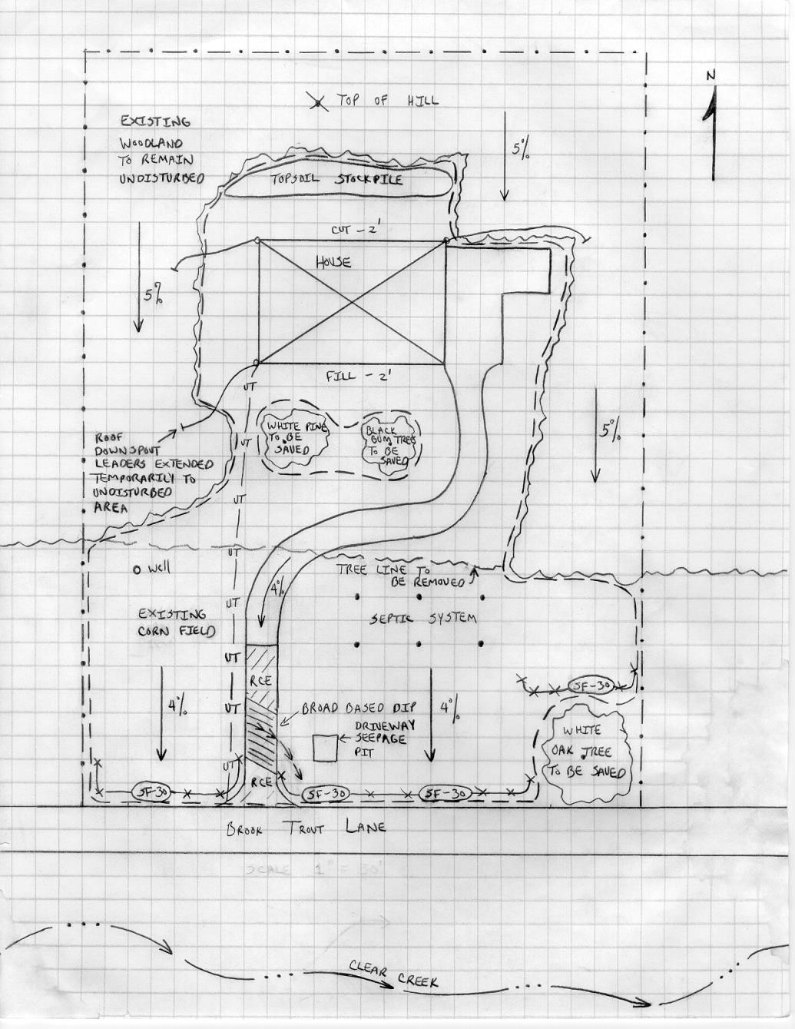
Example of an E&S Plan drawing. Note the presence of a North Arrow, as well as thorough labeling. The addition of a scale bar is strongly recommended.

APPENDIX
Details for Common Best Management Practices (BMPs)

SEEDING MIXTURES
Species Mix Pounds/Acre Pounds/1,000 sq.ft.
Slopes & Banks (non-mowed) Well Drained/Sunny)
Crownvetch plus 10 0.2 (3 oz.)
Tall Fescue, or 20 0.5 (8 oz.)
Perennial Ryegrass 20 0.5 (8 oz.)
Flat, Pea, plus 20 0.5 (8 oz.)
Tall Fescue or 20 0.5 (8 oz.)
Perennial Ryegrass 20 0.5 (8 oz.)
Slopes & Banks (mowed) Variable Drainage/Shaded
Birdsfoot Trefoil, plus 6 0.15 (3 oz.)
Tall Fescue, plus 30 0.7 (11 oz.)
Redtop 3 0.1 (2 oz.)
Tall Fescue, plus 60 1.4 (22 oz.)
Redtop 3 0.1 (2 oz.)
Slopes & Banks (mowed) Well Drained/Shaded
Tall Fescue 60 1.4 (22 oz.)
Red (fine) Fescue, or 35 0.8 (13 oz.)
Kentucky Bluegrass, plus 25 0.6 (10 oz.)
Redtop or 3 0.1 (2 oz.)
Perennial Ryegrass 15 0.3 (3 oz.)
Tall Fescue, plus 40 1.0 (16 oz.)
Red (fine) Fescue 10 0.2 (3 oz.)
Temporary Seedings
Spring Oats, or 96 2.2 (35 oz.)
Winter Wheat, or 180 4.1 (66 oz.)
Winter Rye, or 168 3.8 (62 oz.)
Annual Ryegrass 40 1.0 (16 oz.)

